# Working with Git Repositories- Documentation

1.Create a new repository in GitHub.



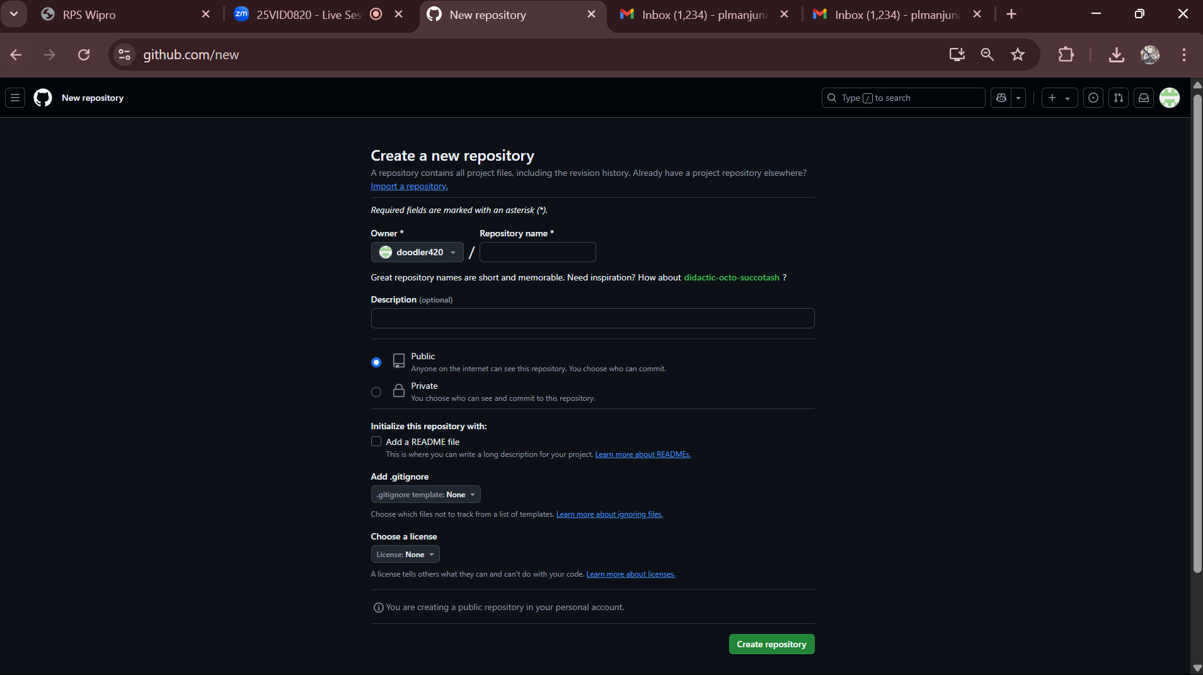

2.Copy the repository URL.

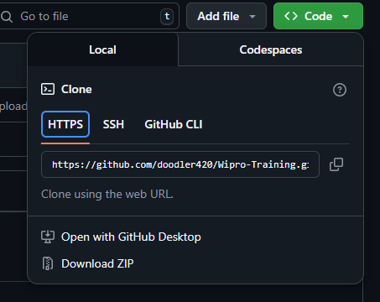

3.Clone the repository into vs code in a folder in C: drive.

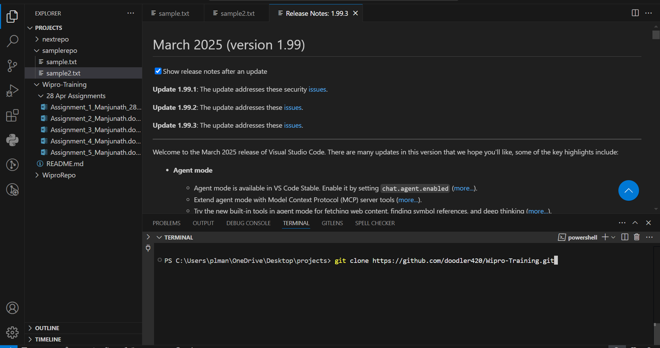

4.Declare global username and email.

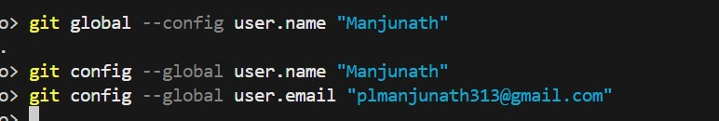

5.Add files into your repository.

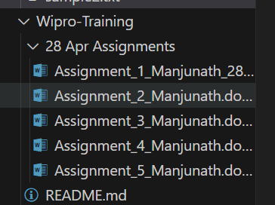

6.Commit and push your changes into the repository. Add a comment.

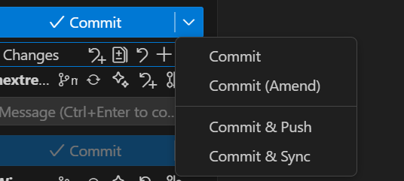

7.Check the GitHub site to see if your changes are committed.

